Name Class Date

2-3

**Reteaching**



Patterns and Nonlinear Functions

If the points of the graph of a function are in a straight line, the function is a  
**linear function.** If the points of the graph of a function are not in a straight line,  
the function is a **nonlinear function.**



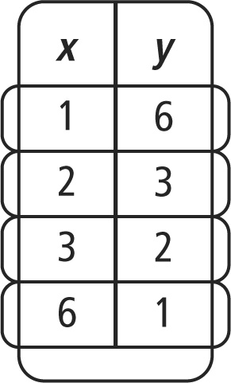Is the function given by the table at the right  
*linear* or *nonlinear*?

Graph the function.

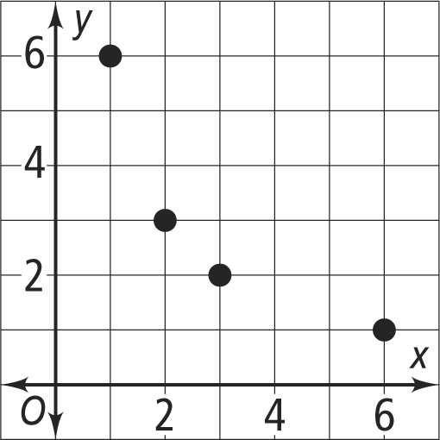

The points are not in a straight line, so the function is nonlinear.

Do you like to solve puzzles? When you are given a list of function values and you are  
asked to find the rule for the function, you are solving a puzzle. You are looking for a  
rule that works for all pairs of numbers.



What is a rule that represents the function given by the table below?

|  |  |
| --- | --- |
|  | Try a rule. Is there an operation or sequence of operations that relates the values in the first column of the table to the values in the second column? |
| Try division: 6 ÷ 2 = 3, but 8 ÷ 2 ≠ 5. |
| Try another rule. 6 – 3 = 3 and 8 – 3 = 5. |
| Check to make sure this works for all pairs of numbers. |
| 9 – 3 = 6 and 12 – 3 = 9. |
| The function can be represented by the rule *y = x* – 3. | |

**Pearson Texas Algebra I**

Copyright © by Pearson Education, Inc., or its affiliates. All Rights Reserved.

Name Class Date

2-3

**Reteaching** (continued)



Patterns and Nonlinear Functions

**Graph the function shown by each table. Tell whether the function is *linear* or  
*nonlinear*.**

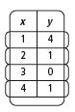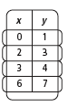

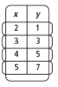

|  |  |  |
| --- | --- | --- |
| **1.** | **2.** | **3.** |
|  |  |  |
| **4.** | **5.** | **6.** |
|  |  |  |

**Each set of ordered pairs represents a function. Write a rule that represents the  
function.**

|  |  |
| --- | --- |
| **7.** (2, 10), (4, 20), (5, 25), (7, 35), (9, 45) | **8.** (2, 5), (4, 9), (5, 11), (7, 15), (10, 21) |
| **9.** (0, 0), (1, 1), (2, 8), (3, 27), (4, 64) | **10.** (2, 5), (3, 10), (4, 17), (5, 26), (6, 37) |

**Pearson Texas Algebra I**

Copyright © by Pearson Education, Inc., or its affiliates. All Rights Reserved.