Name Class Date

2-3

**Practice** *Form G*



Patterns and Nonlinear Functions

**1.** A student’s earnings *E,* in dollars, is a function of the number *h* of hours worked.  
Graph the function shown by the table. Tell whether the function is *linear* or  
*nonlinear*.

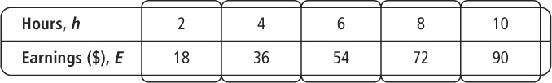

**Graph the function shown by each table. Tell whether the function is  
*linear* or *nonlinear*.**

|  |  |
| --- | --- |
| **172.** | **183.** |

**Pearson Texas Algebra I**

Copyright © by Pearson Education, Inc., or its affiliates. All Rights Reserved.

Name Class Date

2-3

**Practice** (continued) *Form G*



Patterns and Nonlinear Functions

**Each set of ordered pairs represents a function. Write a rule that represents the  
function.**

**4.** (0, 1), (1, 3), (2, 9), (3, 27), (4, 81)

**5.** (0, 0), (1, 1), (2, 4), (3, 9), (4, 16)

**6.** (0, 1), (1, 0.5), (2, 0.25), (3, 0.125), (4, 0.0625)

**7.** (0, 0), (1, 1), (2, 8), (3, 27), (4, 64)

**8.** **Reasoning** A certain function fits the following description: *As the value of x  
increases by 1 each time, the value of y decreases by the square of x.* Is this function *linear* or *nonlinear*? Explain your reasoning.

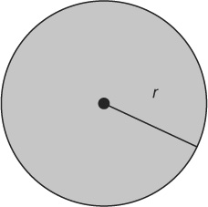

**9.** **Writing** The rule *C* = 6.3*r* gives the approximate  
circumference *C* of a circle as a function of its radius *r*. Identify  
the independent and dependent variables in this relationship.  
Explain your reasoning.

**10.** **Open-Ended** What is a rule for the function represented by  
(0, –2), (1, –1), (2, 2), (3, 7)? Explain your reasoning.

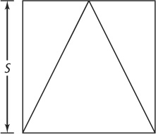

**11.** A landscape architect wants to make a triangular garden inside a  
square of land as shown at the right. What is a rule for the area *A*  
of the garden as a function of *s*?

**Pearson Texas Algebra I**

Copyright © by Pearson Education, Inc., or its affiliates. All Rights Reserved.