Name Class Date

2-3

**Practice** *Form K*



Patterns and Nonlinear Functions

**1.** A worker’s wages *W*, in dollars, is a function of the number *h* of hours worked.  
Graph the function shown by the table. Tell whether the function is *linear* or  
*nonlinear*.

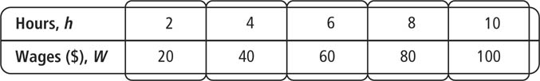

**Graph the function shown by each table. Tell whether the function is *linear*   
or *nonlinear.***

|  |  |
| --- | --- |
| **2.** | **3.** |

**Pearson Texas Algebra I**

Copyright © by Pearson Education, Inc., or its affiliates. All Rights Reserved.

Name Class Date

2-3

**Practice** (continued) *Form K*



Patterns and Nonlinear Functions

**Each set of ordered pairs represents a function. Write a rule that represents   
the function.**

**4.** (0, 0), (1, 1), (2, 4), (3, 9), (4, 16)

**5.** (0, 1), (1, 5), (2, 9), (3, 13), (4, 17)

**6.** (0, −1), (1, 0), (2, 7), (3, 26), (4, 63)

**7.** (0, 2), (1, 1), (2, 0), (3, −1), (4, −2)

**8. Writing** How can you determine if a function is linear or nonlinear from the   
graph of the function?

**9. Error Analysis** A student says that the function shown by the table below can   
be represented by the rule *y* = *x*2 – 1. Describe and correct the error.

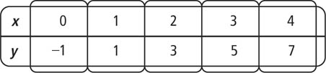

**Pearson Texas Algebra I**

Copyright © by Pearson Education, Inc., or its affiliates. All Rights Reserved.