Name Class Date

2-2

**Reteaching**



Patterns and Linear Functions

A relationship can be represented in a table, as ordered pairs, in a graph, in words,  
or in an equation.



Consider the relationship between the number of squares in the pattern and the  
perimeter of the figure. How can you represent this relationship in a table, as  
ordered pairs, in a graph, in words, and in an equation?



**Table**

For each number of squares determine the perimeter of the figure. Write the  
values in the table. Remember to focus on the perimeter of the figure, not the  
squares.

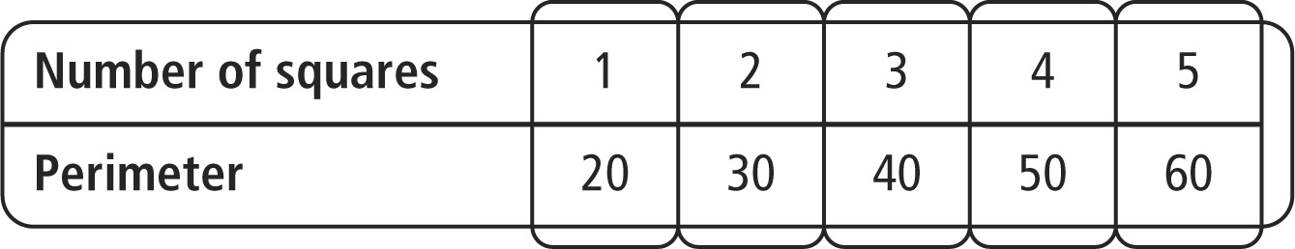

**Ordered Pairs**

Let *x* represent the number of squares and *y* represent the perimeter. Use the  
numbers in the table to write the ordered pairs.

(1, 20), (2, 30), (3, 40), (4, 50), (5, 60)

**Graph**

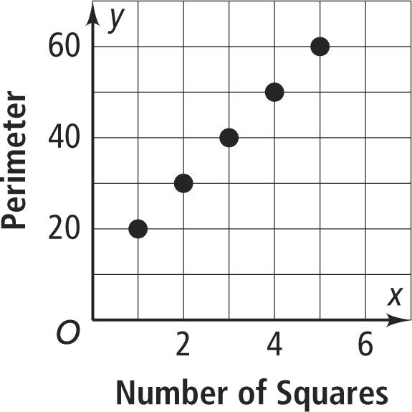

Use the ordered pairs to draw the graph.

**Words**

The pattern shows the perimeter is the number of squares times 10 plus 10.

**Equation**

|  |  |
| --- | --- |
| Write an equation for the words. | *y =* 10*x +* 10 |

**Pearson Texas Algebra I**

Copyright © by Pearson Education, Inc., or its affiliates. All Rights Reserved.

Name Class Date

2-2

**Reteaching** (continued)



Patterns and Linear Functions

**Exercises**

**Consider each pattern.**

|  |  |
| --- | --- |
| **1.** | **2.** |

|  |  |  |
| --- | --- | --- |
| **a.** Make a table to show the relationship between the number of trapezoids and the perimeter. | **a.** Make a table to show the relationship between the number of cubes and the surface area. | |
|  |  | |
| **b.** Write the ordered pairs for the relationship. | | **b.** Write the ordered pairs for the relationship. |
| **c.** Make a graph for the relationship. | **c.** Make a graph for the relationship. | |
|  |  | |
| **d.** Use words to describe the relationship. | **d.** Use words to describe the relationship. | |
| **e.** Write an equation for the relationship. | **e.** Write an equation for the relationship. | |

**Pearson Texas Algebra I**

Copyright © by Pearson Education, Inc., or its affiliates. All Rights Reserved.