Name Class Date

2-2

**Practice** *Form K*



Patterns and Linear Functions

**1.** For the diagram below, find the relationship between the number of shapes and the  
perimeter of the figure they form. Represent this relationship using a table, words,  
an equation, and a graph.

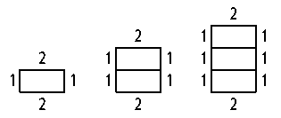

1 rectangle 2 rectangles 3 rectangles

**For each table, determine whether the relationship is a function. Then  
represent the relationship using words, an equation, and a graph.**

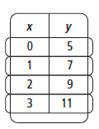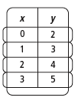**2. 3.**

**Pearson Texas Algebra I**

Copyright © by Pearson Education, Inc., or its affiliates. All Rights Reserved.

Name Class Date

2-2

**Practice** (continued) *Form K*



Patterns and Linear Functions

**For each table, identify the dependent and independent variables. Then  
describe the relationship using words, an equation, and a graph.**

|  |  |
| --- | --- |
| **4.** | **5.** |

**6. Reasoning** Graph the set of ordered pairs (0, 6), (1, 4), (2, 2), (3, 0). Determine  
whether the relationship is a linear function. Explain how you know.

**Pearson Texas Algebra I**

Copyright © by Pearson Education, Inc., or its affiliates. All Rights Reserved.