Name Class Date

2-2

**Practice** *Form G*



Patterns and Linear Functions

**For each diagram, find the relationship between the number of shapes and the  
perimeter of the figure they form. Represent this relationship using a table,  
words, an equation, and a graph.**

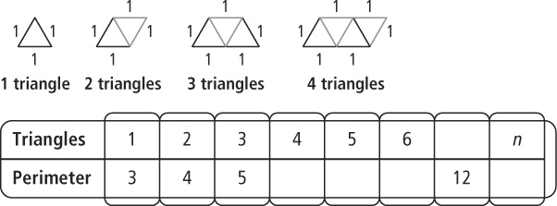

**1.**

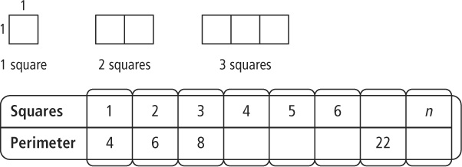**2.**

**For each table, determine whether the relationship is a function. Then  
represent the relationship using words, an equation, and a graph.**

|  |  |
| --- | --- |
| **123.** | **134.** |

**Pearson Texas Algebra I**

Copyright © by Pearson Education, Inc., or its affiliates. All Rights Reserved.

Name Class Date

2-2

**Practice** (continued) *Form G*



Patterns and Linear Functions

**For each table, determine whether the relationship is a function. Then represent the  
relationship using words, an equation, and a graph.**

|  |  |
| --- | --- |
| **145.** | **156.** |

**7.** **Reasoning** Graph the set of ordered pairs (0, 2), (1, 4), (2, 6),  
(3, 8). Determine whether the relationship is a linear function.  
Explain how you know.

**8.** You can make a bubble solution by mixing 1 cup of liquid  
soap with 4 cups of water. Represent the relationship  
between the cups of liquid soap and the cups of bubble  
solution made using a table, an equation, and a graph. Is the  
amount of bubble solution made a function of the amount of  
liquid soap used? Explain.

**Pearson Texas Algebra I**

Copyright © by Pearson Education, Inc., or its affiliates. All Rights Reserved.