Name Class Date

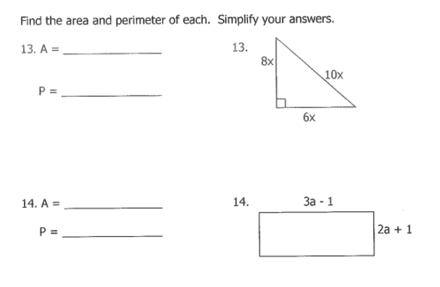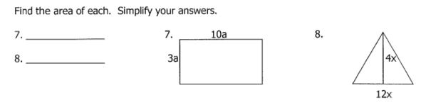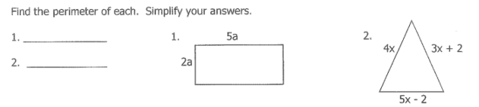7-3**Practice**  *Form K*



Multiplying Binomials

1. A rectangle has length (*x* + 2) in. and width (2*x* + 3) in. Find an expression that  
   represents the area of the rectangle. Write the expression in simplified form.

1. A community center is expanding the size of its rectangular meeting hall. The hall  
   is currently 300 ft long and 150 ft wide. The center plans to expand both the  
   length and the width of the meeting hall by 3*x* ft. Write a polynomial in standard  
   form representing the area of the expanded meeting hall?
2. A rectangular prism has a width of x inches, a length of x2y inches, and a height of y2 inches. What is the volume in cubic inches of this rectangular prism?

**Pearson Texas Algebra I**

Copyright © by Pearson Education, Inc., or its affiliates. All Rights Reserved.