Name Class Date

2-1

**Reteaching**



Using Graphs to Relate Two Quantities

An important life skill is to be able to a read graph. When looking at a graph, you  
should check the title, the labels on the axes, and the general shape of the graph.



What information can you determine from the graph?

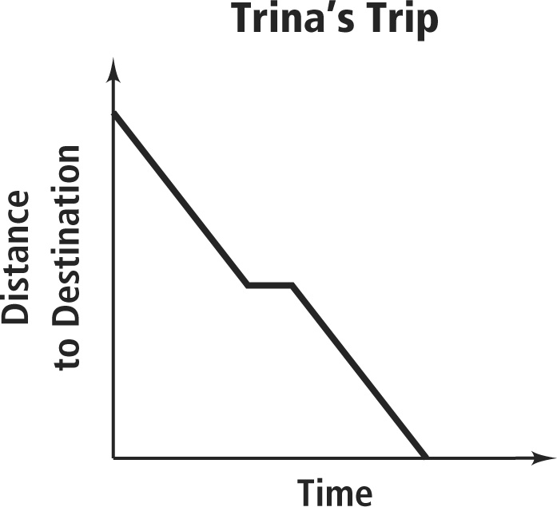• The title tells you that the graph describes Trina’s trip.

• The axes tell you that the graph relates the variable of  
time to the variable of distance to the destination.

• In general, the more time that has elapsed, the closer  
Trina gets to her destination. In the middle of the trip,  
the distance does not change, showing she stops for a  
while.

**Exercises**

**What are the variables in each graph? Describe how the variables are related at  
various points on the graph.**

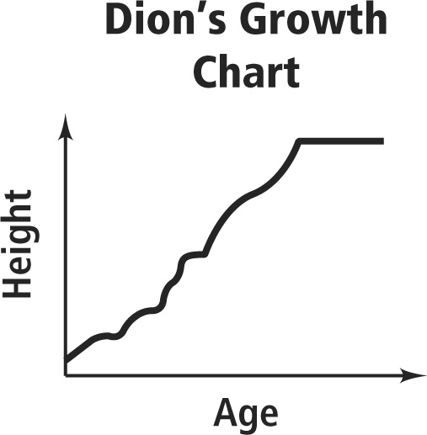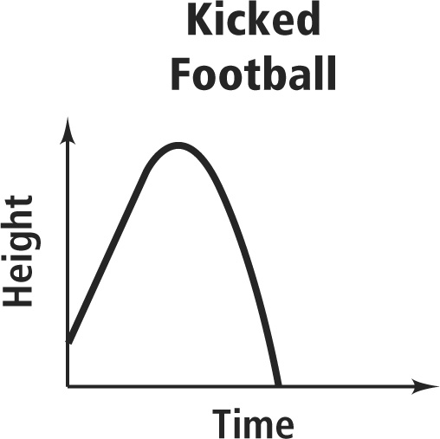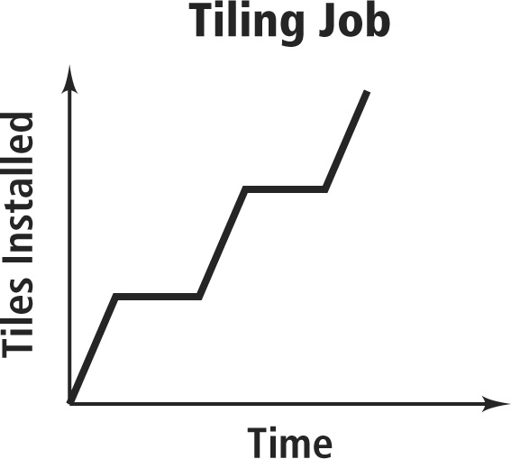**1. 2. 3.**

**Pearson Texas Algebra I**

Copyright © by Pearson Education, Inc., or its affiliates. All Rights Reserved.

Name Class Date

2-1

**Reteaching** (continued)



Using Graphs to Relate Two Quantities

A graph can show the relationship described in a table.



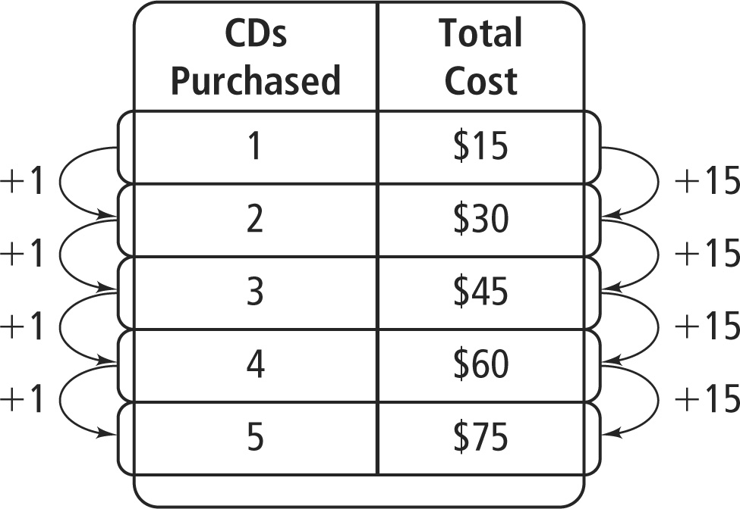

Which graph shown below represents the  
information in the table at the right?

Notice that for each additional CD purchased, the  
total cost increases by $15. The points on the graph  
should be in a straight line that goes up from left to  
right. The graph that shows this trend is Graph B.

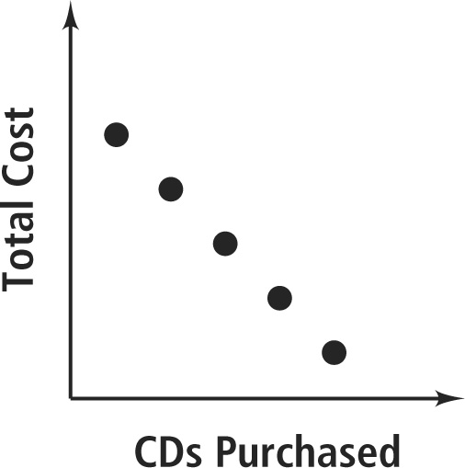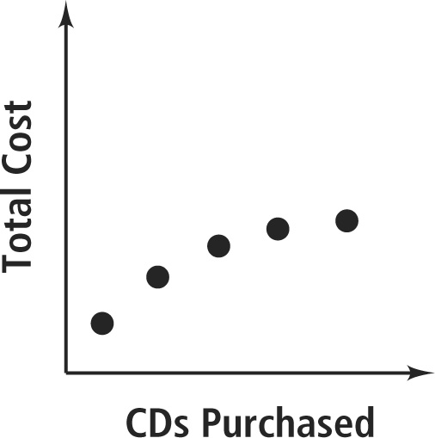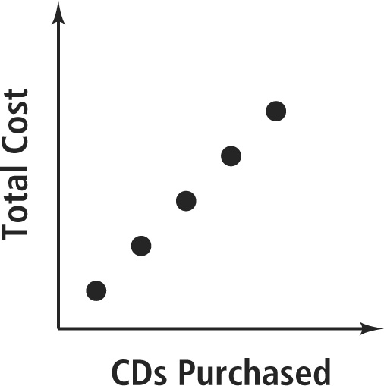**A. B. C.**

**Exercises**

**Match each graph with its related table. Explain your answers.**

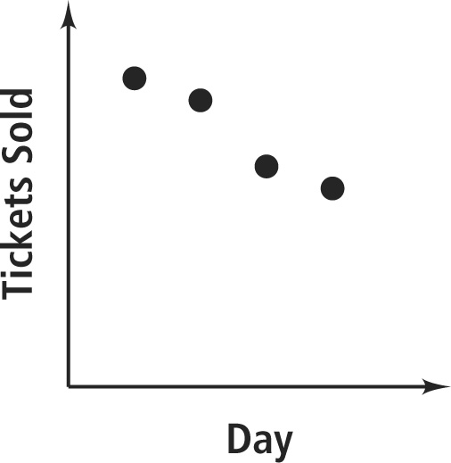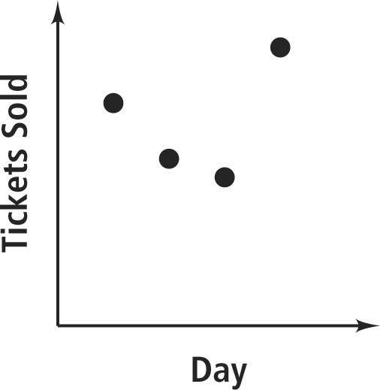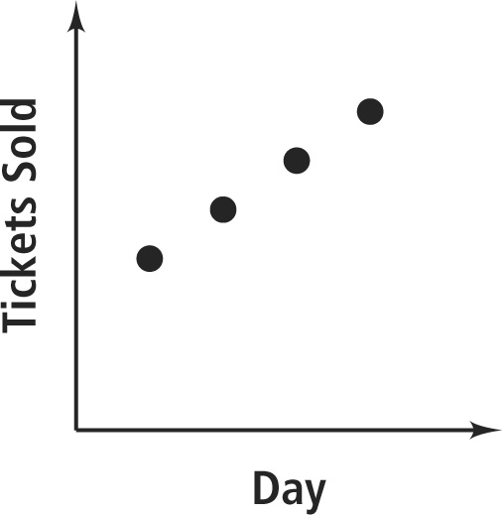**4. 5. 6.**

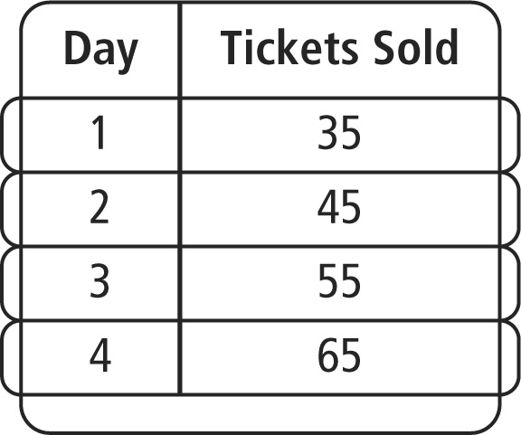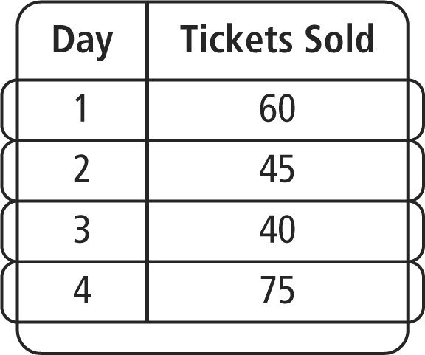

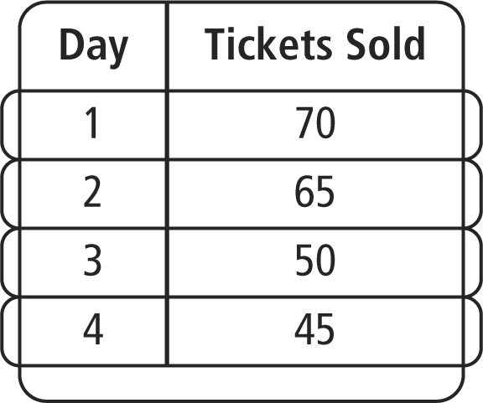**A. B. C.**

**Pearson Texas Algebra I**

Copyright © by Pearson Education, Inc., or its affiliates. All Rights Reserved.