Name Class Date

2-1

**Practice** *Form G*



Using Graphs to Relate Two Quantities

**What are the variables in each graph? Describe how the variables are related at  
various points on the graph.**

|  |  |  |
| --- | --- | --- |
| **11.** | **22.** | **33.** |

**Match each graph with its related table. Explain your answers.**

|  |  |  |
| --- | --- | --- |
| **44.** | **55.** | **66.** |
| **7A.** | **8B.** | **9C.** |

**Pearson Texas Algebra I**

Copyright © by Pearson Education, Inc., or its affiliates. All Rights Reserved.

Name Class Date

2-1

**Practice** (continued) *Form G*



Using Graphs to Relate Two Quantities

**Sketch a graph to represent the situation. Label each section.**

**7.** You buy two shirts. The third one is free.

**8.** You warm up for gym class, play basketball, and  
then cool down.

**9.** The temperature warms up during the day and  
then decreases at night.

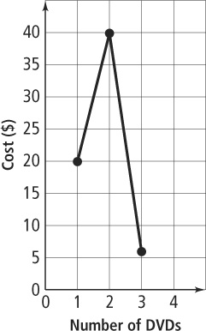**10. Error Analysis** DVDs cost $19.99 each for the first 2  
purchased. After that, they cost $5.99 each. Describe and  
correct the error in sketching a graph to represent the  
relationship between the total cost and the number of DVDs  
purchased.

**11.** Sketch a graph of each situation. Are the graphs the same? Explain.

**a.** your distance from school as you leave your house and walk to school

**b.** your distance from school as you leave school and walk to your house

**Pearson Texas Algebra I**

Copyright © by Pearson Education, Inc., or its affiliates. All Rights Reserved.