Name Class Date

2-1

**Practice** *Form K*

Using Graphs to Relate Two Quantities

**What are the variables in each graph? Describe how the variables are related at  
various points on the graph.**

|  |  |
| --- | --- |
| **1.** | **2.** |

**Match each graph with its related table.**

|  |  |  |
| --- | --- | --- |
| **3.** | **4.** | **5.** |

|  |  |  |
| --- | --- | --- |
| **A.** | **B.** | **C.** |

**Pearson Texas Algebra I**

Copyright © by Pearson Education, Inc., or its affiliates. All Rights Reserved.

Name Class Date

2-1

**Practice** (continued) *Form K*



Using Graphs to Relate Two Quantities

**Sketch a graph to represent each situation.**

**6.** During a trip, your speed increases during the first hour and  
decreases over the next 2 hours.

**7.** The average temperature steadily decreases over the course of the  
football season.

**8.** The average test score of the class increased throughout the  
semester until it decreased slightly on the last test.

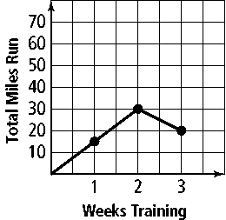**9. Error Analysis** During the first 2 weeks of training,  
Shelly ran 15 miles per week. Then, she increased to  
20 miles per week. Describe and correct the error in  
sketching a graph to represent the relationship between  
the weeks and the total number of miles she has run.

**Pearson Texas Algebra I**

Copyright © by Pearson Education, Inc., or its affiliates. All Rights Reserved.