Name Class Date

2-4

**Reteaching**



Graphing a Function Rule

By finding values that satisfy a function rule, you can graph points and discover the  
shape of its graph.



What is the graph of the function rule *y =* 3*x +* 5?

|  |  |
| --- | --- |
| First, choose any values for *x* and find the corresponding values of *y*. Make a table of your values. | Then, graph the points from your table. In this case, the points are in a line. Draw the line. |
|  |  |



What is the graph of the function rule *y =* |*x* – 2|?

|  |  |
| --- | --- |
| First, choose any values for *x* and find the corresponding values of *y*. Make a table of your values. | Then, graph the points from your table. In this case, the points make a V shape. Draw the V. |
|  |  |

**Pearson Texas Algebra I**

Copyright © by Pearson Education, Inc., or its affiliates. All Rights Reserved.

Name Class Date

2-4

**Reteaching** (continued)



Graphing a Function Rule

**Exercises**

**Graph each function rule.**

|  |  |
| --- | --- |
| **1.** | **2.** *y =* –*x* – 3 |

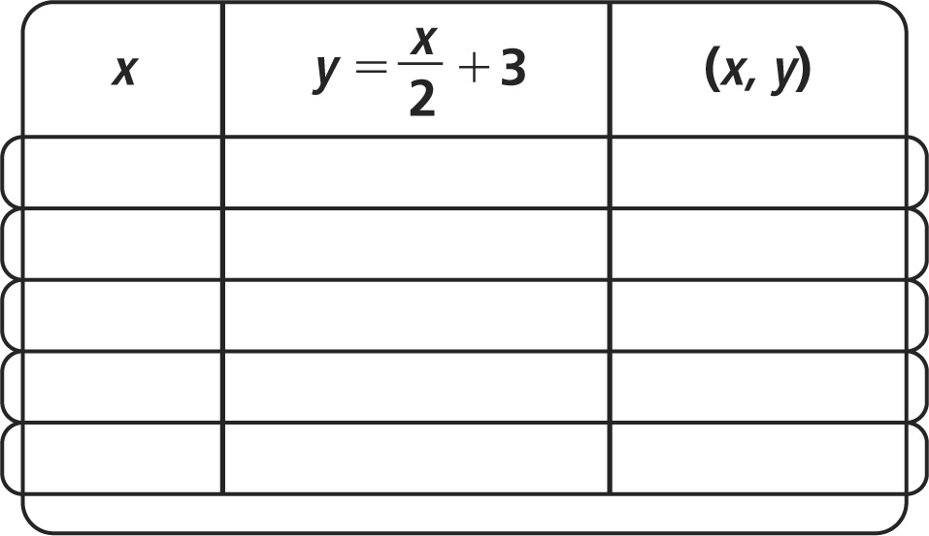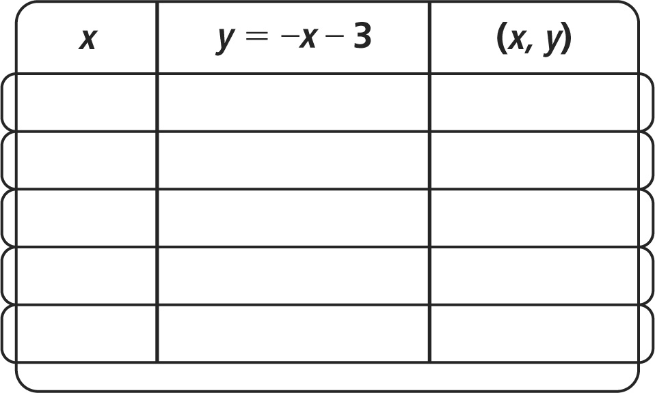



**3.** *y* ***=*** *x*2***–*** 3 **4.** *y* ***=* |***x***|+**1

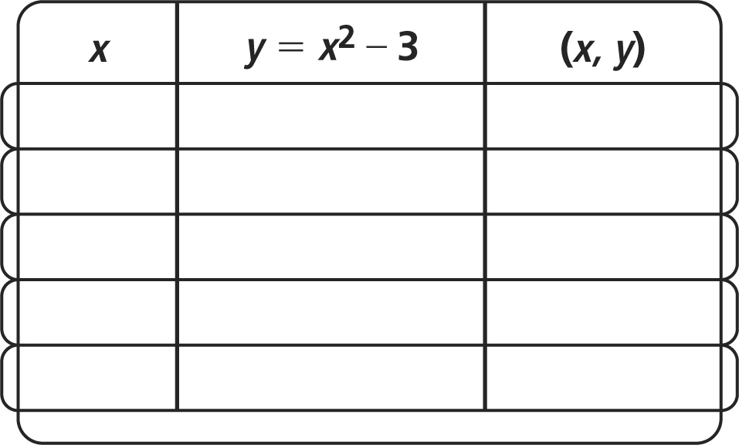

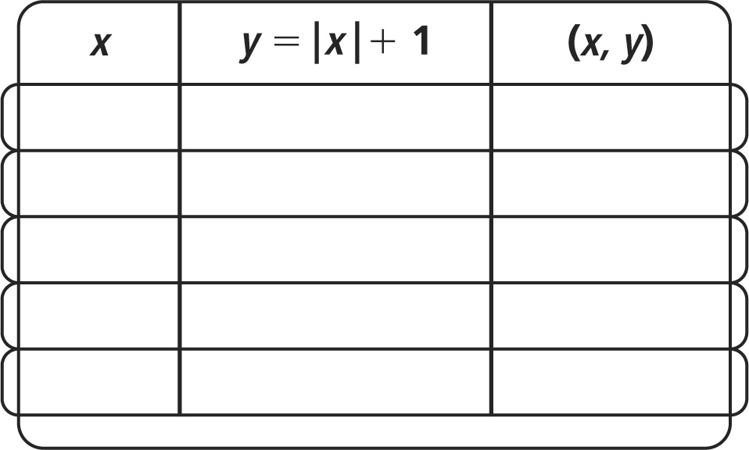



**Pearson Texas Algebra I**

Copyright © by Pearson Education, Inc., or its affiliates. All Rights Reserved.